Bradley Lamitie

Assigned 8/30/2016

Due 9/6/2016

Assignment 1

Data Communications – Matheus

1. <http://testinternetspeed.org/> reported that my download speed is 57.54 Mbps and upload speed is 4.15Mbps. Home Ethernet Cat-5.

<http://www.speedtest.net/> reported that my download speed is 56.84 Mbps and upload speed is 26.51 Mbps. Home Ethernet Cat-5.

1. Panko.com’s Ip address is **97.74.215.128 .** 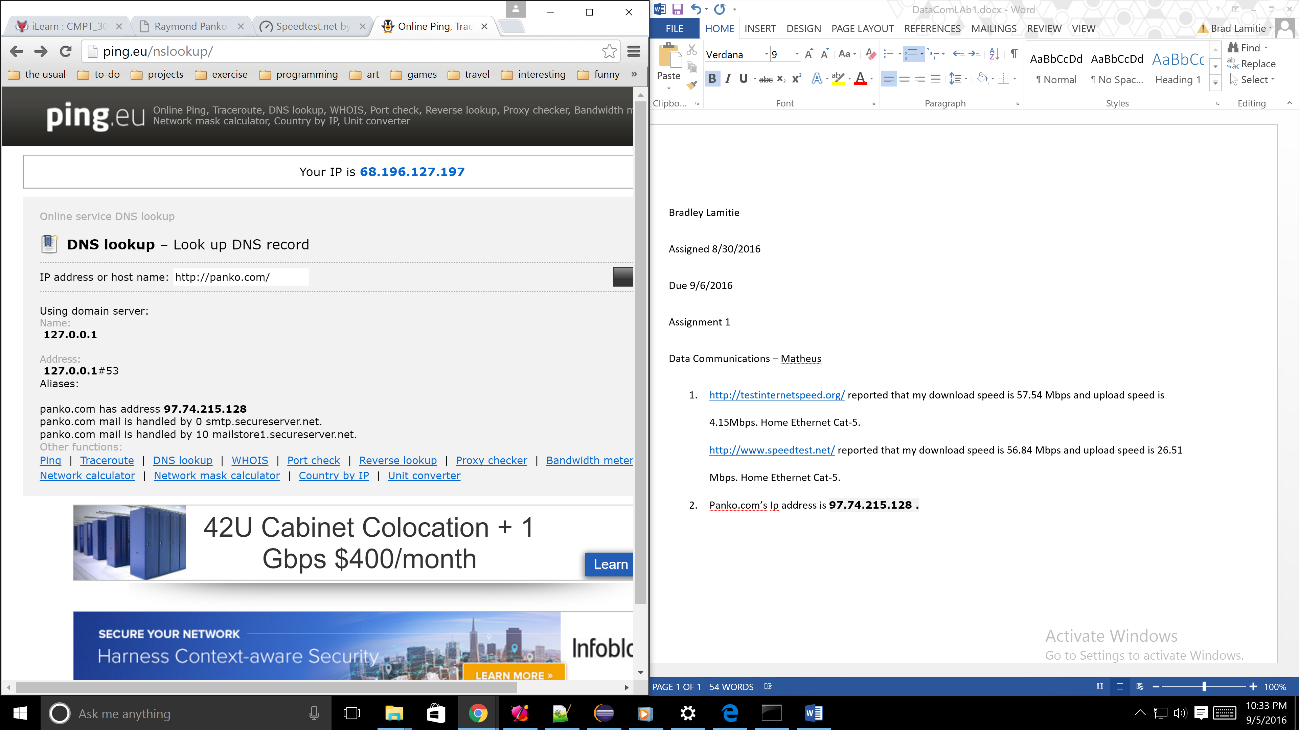
2. 